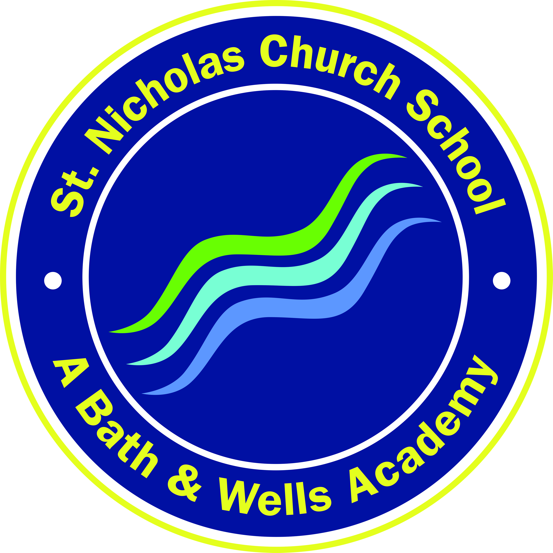
St. Nicholas Church School
Kilmersdon Road, Radstock
BA3 3QH

Tel: 01761 432101
Email: enquiries@stnicholas.bwmat.org
Website: www.stnicholasschool.co.uk

Wellow Welcome Meeting Information

Dear Parents/Carers,

We hope that your child has enjoyed their start to a new term in Wellow Class. This letter provides some of the key bits of information discussed during our Welcome Meeting. The slides from the meeting will be available on our class page of the school website.

Wellow Class Staff
Teacher: Miss. Parrott (Mon-Fri)
Teaching Assistants: Mrs. Lamb (Mon – Wed) Mrs. Wilkinson (Thurs-Fri) Mrs. Turner (Mon-Fri)

Reading
Your child needs to read at least 3 times a week. Every time they read their Reading Record needs to be filled in and signed. Reading books are kept for at least a week to develop fluency and confidence. An additional book will be sent home for you to read to your child and enjoy together. Encourage your child to talk about the pictures, storyline, and characters.

Sounds Folder
Each child has a sounds folder. Please practise these regularly at home and bring back everyday in the book bag.

PE Kits
Our PE lesson is on a Monday. Please make sure your child has their PE kit in school all week in case of any changes to timetable/additional sessions/ as well as our regular move a mile sessions. PE kits will be sent home every Friday to be washed and should be returned on Monday.

Pick up
Parents need to let your teacher know if you are being collected by somebody different at the end of the day. Please do this by communicating with a Wellow member of staff or messaging the office.

Home/ School Communication
Messages between parents/carers and teachers can be passed on at drop off and pick up times. It is useful to pass on messages about your child, for example if something is worrying them or if something has happened at home which may impact them at school. Children arriving at school in a taxi will receive a phone call once a week to catch up and discuss any concerns.

Water Bottles
Please make sure your child has a named water bottle in school. This bottle will come home at the end of each week to be cleaned.

Wellies
Children in Wellow Class regularly have access to the forest area within the school grounds. We have recently purchased some outdoor clothing, but could you provide a pair of wellies to remain in school.

Wellow Class are pleased to be back in school with their friends. We are looking forward to the many fun learning opportunities we have planned and we can’t wait to help your child progress.

Yours Faithfully,

Mrs. Turner Miss. Parrott Mrs. Wilkinson Mrs. Lamb

