St Nicholas Church School
Welcome Meeting Information
Year….

Dear Parents/Carers,

We hope that your child has enjoyed their first few weeks in Yeo Class. This letter provides some of the key bits of information from our Welcome Meeting.

Yeo Class Staff
Teacher: Miss King
Teaching Assistants: Mrs Clarke, Mrs Smith and Mrs Wilkinson
Reading
Your child needs to read at least 3 times a week but ideally every day. Every time they read, please fill in their reading record. Reading Records are checked every morning and reading books will be changed as needed.
PE Kits
Our PE lessons are on a Monday and Thursday. Please make sure your child comes in PE kit on these days. Please ensure the PE kit follows our Uniform policy.
Pick up
Parents need to let your teacher know if you are being collected by somebody different at the end of the day. Please do this by notifying the office.
Homework
Please see the homework policy on our website for more details
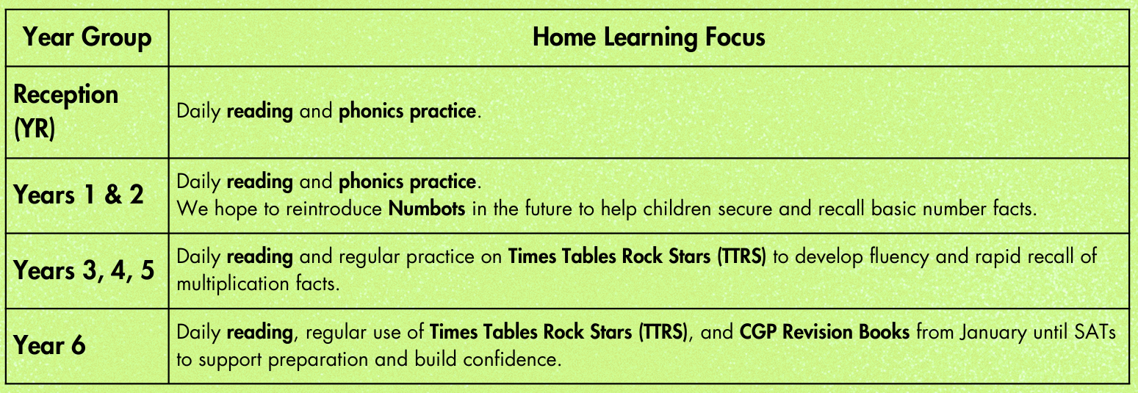

Art Shirts
Please provide your child with an old t-shirt for art. This needs to be big enough to go over their own clothes.
Water Bottles
Please make sure your child has a named water bottle in school. This bottle will need to come home at the end of each day to be cleaned.
Stationery
We provide all the stationery your child will need in school. Your child should not be bringing in stationery from home, including pencil cases, pens or pencils. Thank you for your support with this.

We are all excited about the academic year ahead. We are looking forward to the many fun learning opportunities we have planned, and we can’t wait to help your child progress.

Many thanks

Miss King

